**Use Case UC1: Play New Game**

**Scope:** Chewy Lokum Legend Game

**Level:** User-goal

**Primary Actor:** Player

**Stakeholders and Interests:**

* Player: Wants to play the game without any problems.

**Preconditions:** The player is in front of the computer and ready for playing the game.

**Success Guarantee (or Post conditions):** Player successfully or unsuccessfully completes the level. Score is calculated. Player’s level is saved and he/she is rewarded with Striped Lokums if the level is successfully completed.

**Main Success Scenario (or Basic Flow):**

1. The player presses Play Button.
2. The game board is loaded to the screen with lokums, level info and the target score.
3. Player swaps the position of two adjacent lokums horizontally, vertically, or diagonally. Number of moves is decreased.
4. Vertically or horizontally adjacent group of three lokums are formed.
5. These three lokums are removed from the board.

6. Score is updated with 60 points.

7. The lokums above fall to fill in the empty space.

8. Open spaces at the top of the board are filled with randomly chosen lokums.

*Player repeats step 2-7 until, number of moves are 0 or the score for the level is reached.*

1. Player is successfully completed the level and can proceed to the next level.

**Extensions (or Alternative Flows):**

3-7a. No group is formed when two lokums are swapped:

1. Two lokums swap back to their old positions.

3-5b. When 4 consecutive same colored lokums are combined:

1. Striped Lokum, a special type of lokum is formed.
2. Score is updated with 120 points.

3-5c. When 5 same colored lokums form a ‘T’ shape:

1. Wrapped Lokum, a special type of lokum is formed.
2. Score is updated with 200 points.

3-5d. When 5 consecutive same colored lokums are combined:

1. Color Bomb Lokum, a special type of lokum is formed.
2. Score is updated with 200 points.

3-5e. Vertically or horizontally adjacent group of three lokums are formed with a special lokum:

1a. If the special lokum is a striped lokum:

1. An entire row or column of lokums are cleared.
2. Score is updated with n*60 points, where n is the number of lokums cleared.

1b. If the special lokum is a wrapped lokum:

1. Acts like a bomb and clears the surrounding 8 lokums, falls and explodes one more time (clears the surrounding 8 lokums again).
2. Score is updated with 1080 points.

3-5f. Color Bomb Lokum is used:

1. All lokums with the same color of the one the color bomb lokum is matched with are removed from the board.
2. Score is updated with n^2 * 60 points where n is the number of lokums cleared.

3-5g. When two special lokums are combined:

1a. If the combo is striped + striped:

1. An entire row and column of lokums are cleared.

1b. If the combo is striped + wrapped:

1. Three rows and three columns of lokums are cleared.

1c. If the combo is wrapped + wrapped:

1. Score is updated with 3600 points.

1d. If the combo is striped + color bomb:

1. N number of striped lokums (either vertical or horizontal which is assigned randomly) will be created, where “n” is the number of lokums that are the color of the lokum the player matched the color bomb with.

1e. If the combo is wrapped + color bomb:

1. Lokums that are the same color, as the wrapped candy will be cleared. Another random colored lokums will be cleared as well. 1d. If the combo is color bomb + color bomb:
2. Score is updated with n^2 * 100 points where “n” is the number of lokums on the board.

9a. Player did not reach to the minimum score of the level:

1. Player cannot proceed to the next level and has to play the same level again.

7a. If destroying a set of lokums cause another set to form:

1. Player will receive x2 points.

**Special Requirements:**

* After the player presses the Play Button, the game should start within 0.4 seconds.

**Technology and Data Variation List:**

**Frequency Of Occurrence:**

Every time the user wants play the game.

**Open Issues:**

-

**Use Case UC2: Save Game**

**Scope**: Chewy Lokum Legend Game

**Level:** User-goal

**Primary Actor:** Player

**Stakeholders and Interests:**

- Player: able to save the state of a game at any level, and is able to resume from this saved state.

**Preconditions:** Player is playing a game, and level to be saved is not completed.

**Success Guarantee (or Post conditions):** The last state of the game is saved, if player opens the game again last state of the game is saved. Information for current score, board state and remaining moves for the next level are recorded.

**Main Success Scenario (or Basic Flow):**

1. Player clicks the ‘Save’ button.
2. Game is saved

**Alternative Flows:**

*a. If a device dependent problem occurs, and game is not saved,

1. System signals error to player,
2. Game restarts from the last played level.

**Special Requirements:**

* Save should be done time efficiently.

**Technology and Data Variations List:**

XML schema will be used to for the data of the saved state.

**Frequency of Occurrence:** Depends on user, could be frequently

**Open Issues:**

**Use Case Model Diagram**

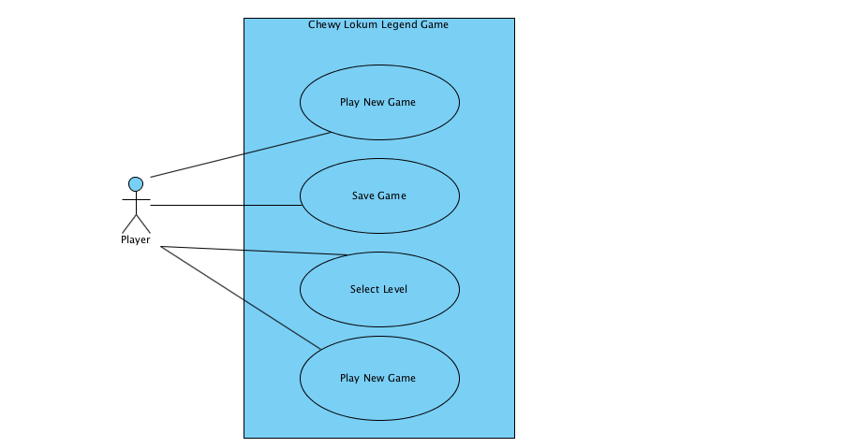

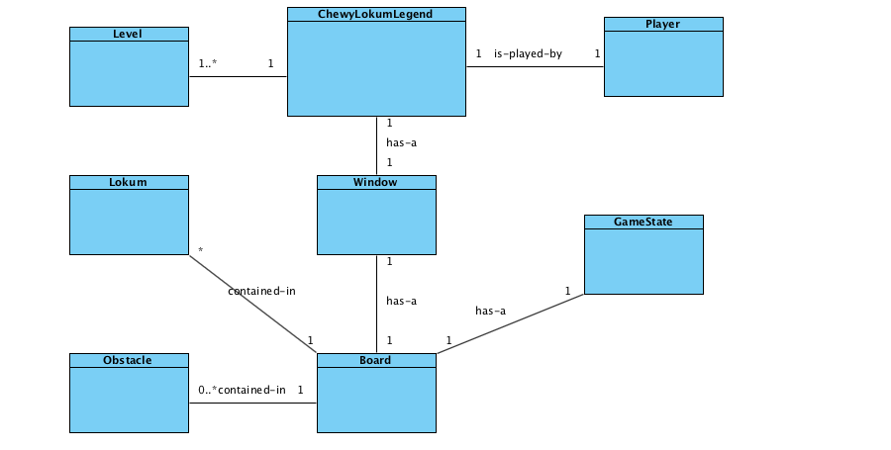**Domain Model**

**System Sequence Diagram**

***Play New Game System Sequence Diagram***

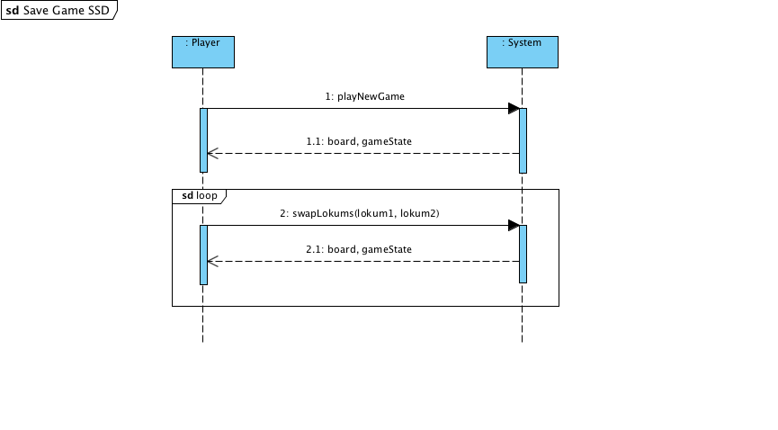

***Save Game System Sequence Diagram***

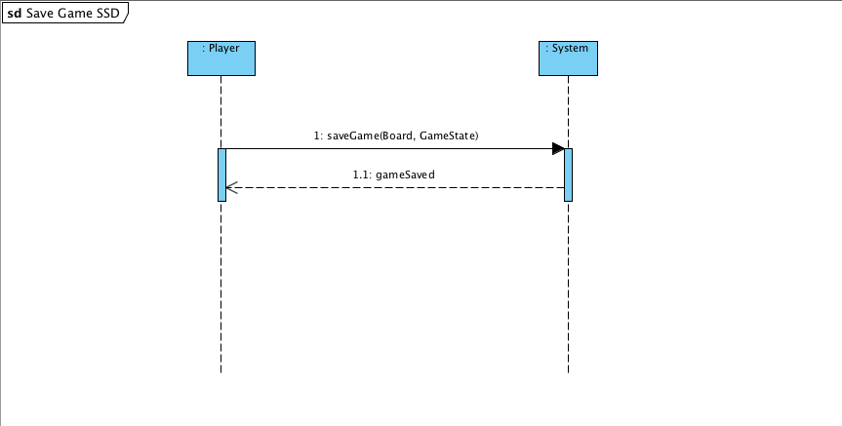

**Contract CO1: saveGame**

Operation: Cross saveGame(Board, GameState)

References: Use Cases: Save Game

Preconditions: - Game is being played and not finished.

Post conditions: - GameState is saved.

**Contract CO2: swapLokums**

Operation: Cross swapLokums(Lokum1, Lokum2)

References: Use Case: Play New Game

Preconditions: - Game is active.

- Differend but adjacent lokums are selected.

Post conditions: - Lokums are swapped if they are available.

- GameState is updated.